**POWER BI ASSIGNMENT-12**

**Use Case –** Working with Bookmark as action.

**Source - Zoo**

**Analytics –** Create Bookmark

Q1. Try to make a report which has a page for each kind of image. When you click the image of that creature you will see all the animals of the same type:

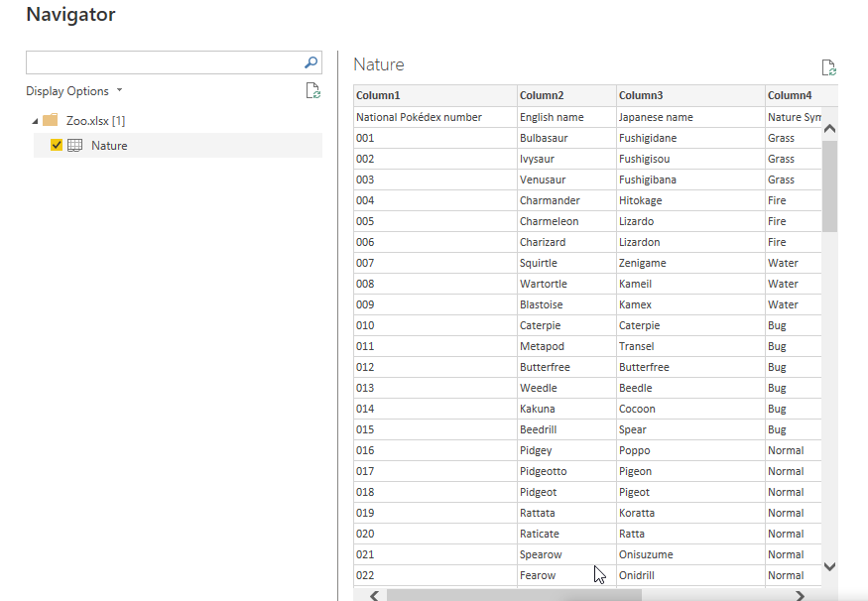

Step-2. Now click on water image and switch on action for it and assign bookmark as an action

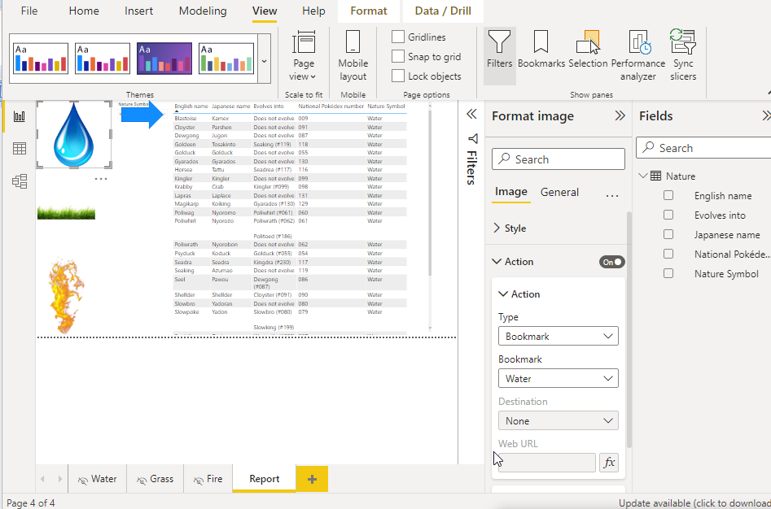

Step-3. click on Fire image and switch on action for it and assign bookmark as an action and select relevant bookmark for that image as shown below.

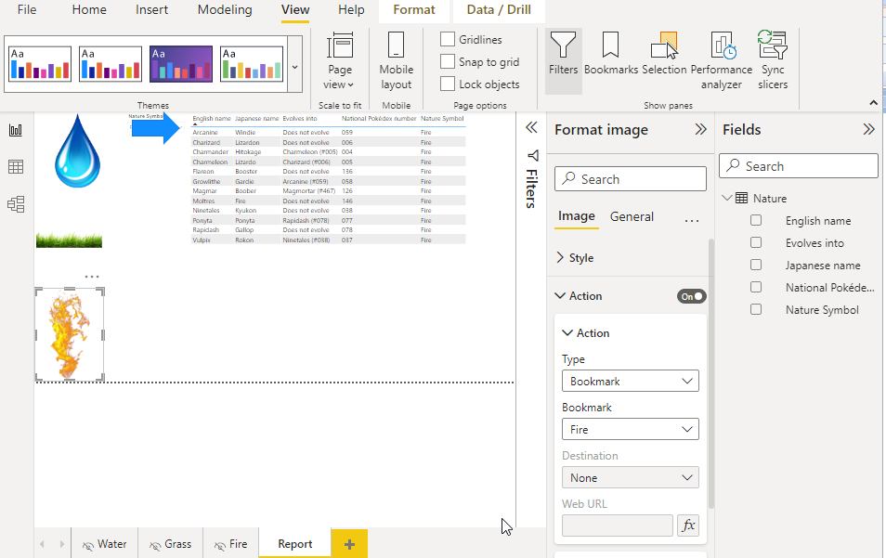

Step-4. click on grass image and switch on action for it and assign bookmark as an action and select relevant bookmark for that image as shown below.

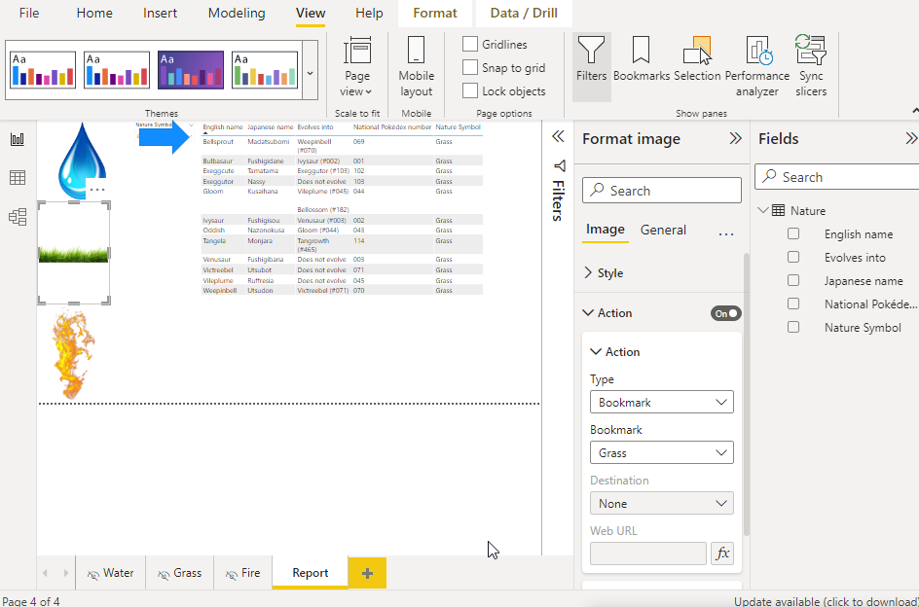

Step-5. Insert a backward arrow mark on each page and assign backward action for it.

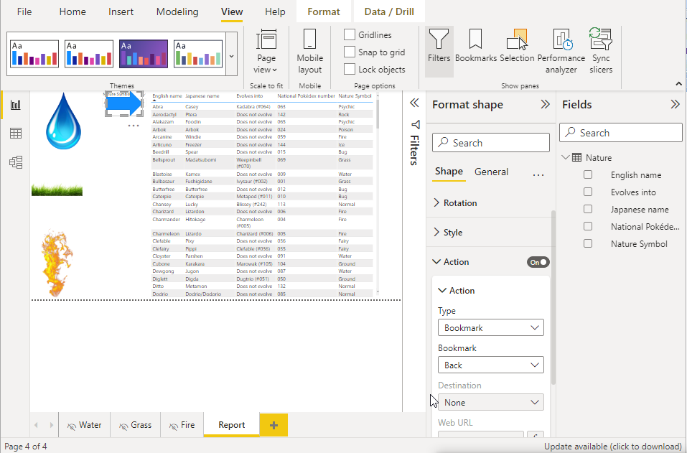

.Save and publish in power bi service as Zoo

